To measure our success in fighting climate change, we must look at one primary figure: the concentration of GHG emissions in the atmosphere. It turns out that the extent to which production contributes every year to such concentration depends greatly on its sectoral composition. This is because technologies used across sectors vary widely. For example, cement manufacturing depends on carbon-intensive combustion technologies for heating and cooling, while the business services sector is driven primarily by human interaction, a naturally low-carbon technology.
This is why the economic implications of climate policy differ greatly across sectors – it is supposed to punish carbon-intensive sectors more severely. But, such sectoral implications do not only depend on the direct emissions during production: an activity like business services requires the construction sector to build offices made with cement, steel beams, glass, etc. So, understanding a given sector or firm’s vulnerability to climate policy is not only about how much it emits directly, but also about how much your needed suppliers emit. In fact, corporate reporting standards aspire to require disclosure across three categories to cover this: Scope 1 (direct emissions), Scope 2 (indirect emissions from purchased electricity), and Scope 3 (all other emissions within the value chain, both upstream and downstream).
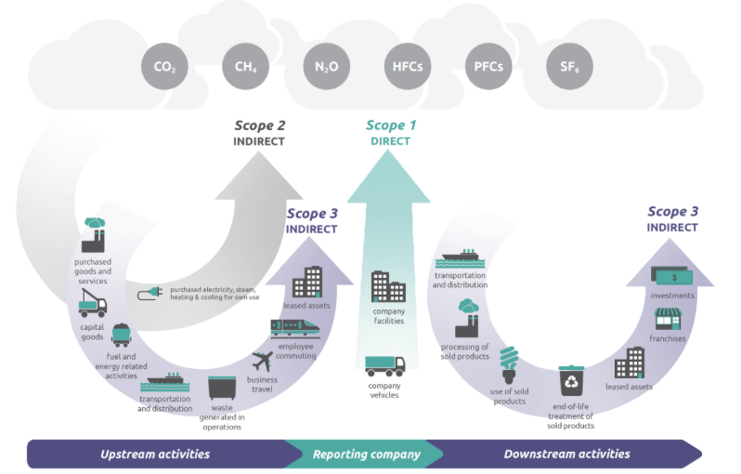
Source: U.S Environmental Protection Agency (EPA). Emissions by Scope inventory guidance.

The Data
A useful tool to analyze direct and indirect emissions across sectors are Input-Output tables. Understanding these at a global level gets unnecessarily complicated, so let's focus on the Spanish economy.
Input-Output tables contain the output produced by each sector, as well as the inputs that each sector buys from other sectors. Therefore, the table of interest looks as follows:
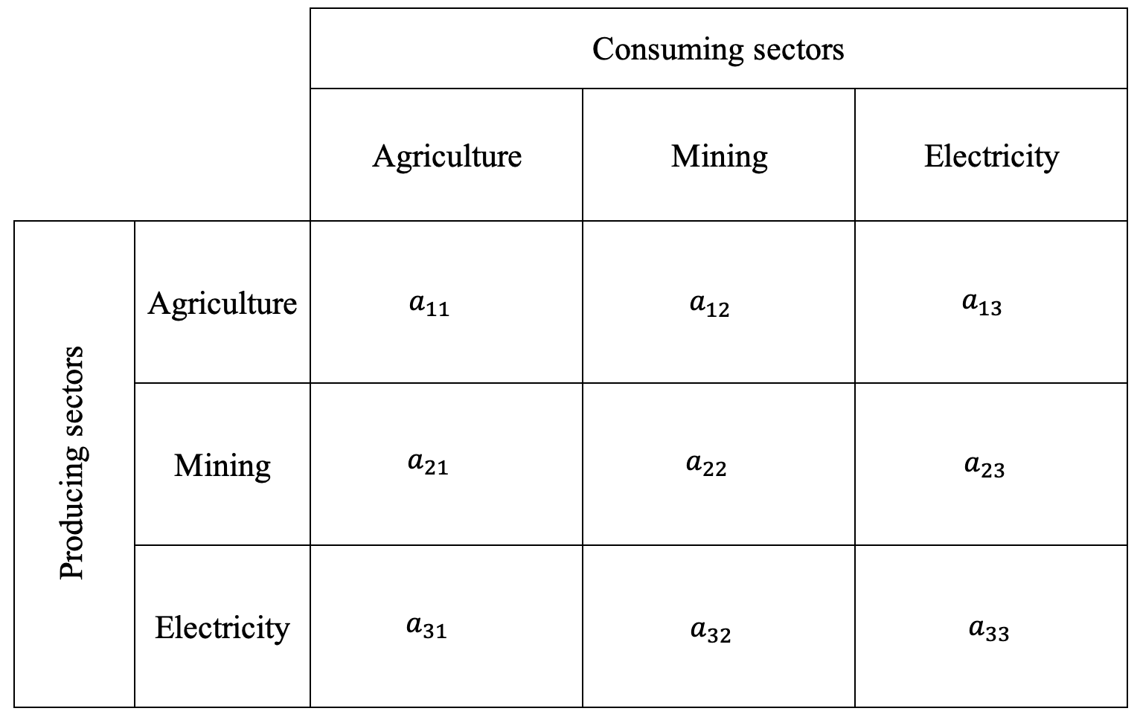
Source: Input-Output table. Own elaboration

The rows correspond to the producing sectors, and columns to the consuming sectors. Therefore, for example, the agriculture row shows agricultural output sold to each consuming sector. The $a_{11}$ cell would therefore be the agricultural output sold to the agricultural sector, which is usually zero but sometimes positive: think of grain (output) used as seed (input) for the next planting season). The $a_{12}$cell would be the agricultural output sold to the mining sector, and so on.

EXIOBASE provides this table for 44 economies across 163 sectors. Moreover, EXIOBASE also provides the Scope 1 GHG emissions for each of these country-sectors, so half of our work is already done (Scope 1 emissions). For the other half (Scope 2 and 3 emissions), we will need to borrow a Nobel Prize winning idea…

The Classical Leontief Model
While the Input-Output table provides the "recipe" for production, that only tells us about the direct requirements. For example, we can see exactly how much electricity the agricultural sector purchases to produce its own output. However, for any sector, the upstream supply chain does not stop there. The electricity suppliers need their own inputs such as fuel and infrastructure to operate. And fuel and infrastructure suppliers also need their own inputs to supply to electricity producers. Therefore, final demand for agricultural output triggers a whole chain of production across supplying sectors.
This is where the Nobel prize-winning Leontief Inverse model comes in. Check the appendix if you are brave enough to go into algebra. It accounts not only for the direct input requirements of a sector, but also for such a chain of production across supplying sectors. As a result, you end up with a matrix structured in the same way as the Input-Output table, but that shall be interpreted differently.
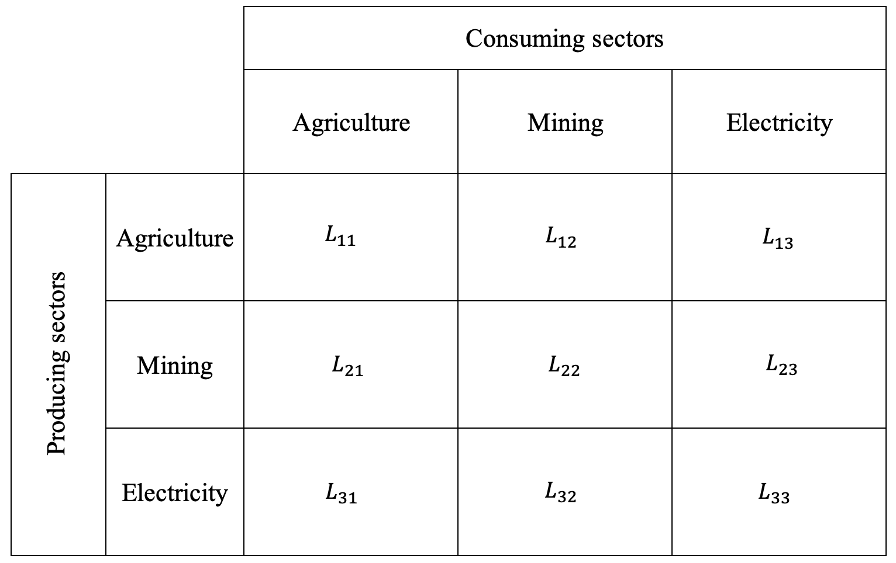
Source: Leontief Inverse matrix. Own elaboration.
Now, $L_{31}$ does not only include the electricity consumed by the agricultural sector, but also the electricity needed by the suppliers of the electricity sector, and the electricity needed by the suppliers of the suppliers, and so on. Given this framework however, how do we translate all these upstream production requirements into emissions?

The Leontief Environmental Extension
As mentioned previously, EXIOBASE does not only provide Input-Output tables on monetary terms, but also what are called satellite accounts. These are tables which follow the same sectoral classification as the Input-Output table, and contain information about the sector’s associated water use, nutrient use, raw material use, and most importantly for this exercise, emissions. Therefore allowing us to extend analysis to variables that matter for welfare and sustainability.
To turn the Leontief matrix into an emissions map, each cell ought to be multiplied by its corresponding producing sector’s emission intensity, which is just the sector’s total pollution divided by its total output. Essentially, you're taking the economic data and scaling it by a "pollution per dollar" rate to see the actual environmental impact. This calculation transforms the matrix from a web of economic transactions into a clear picture of total emissions required by each sector. Where, $L_{31}$ is the electricity input needed to produce agricultural output accounting for the full chain of supplying production, and $e_{elec}$ is the direct emission intensity of electricity providers.
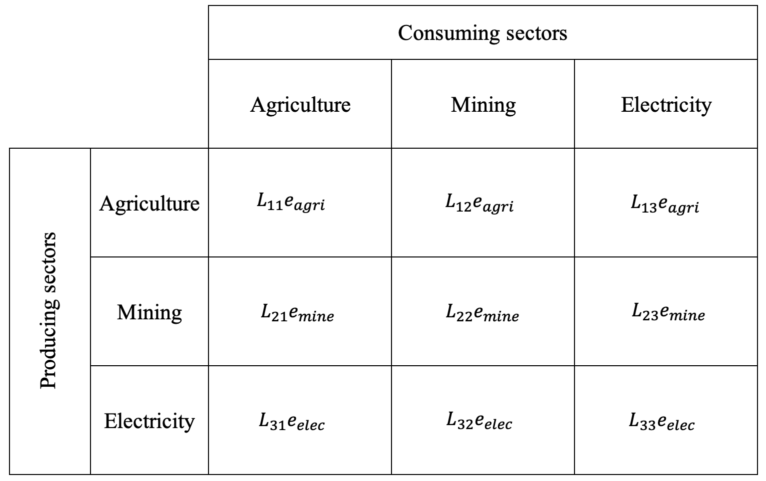
Source: Environmentally scaled Leontief Inverse matrix. Own elaboration.

It must be noted that there are two main limitations that come with this approach. First, the Leontief model only recovers the upstream production requirements, but it does not take into account the downstream chain of events shown by the last arrow on the right in Figure 1, missing a key area of Scope 3 emissions. The Leontief inverse does not track what happens to the agricultural products afterward. The crops may be processed into packaged foods, transported across countries, sold through retail chains, and ultimately consumed by households, each stage generating additional emissions that are not attributed back to the agricultural sector in the standard Leontief framework. Therefore, we account for Scope 1 and 2 emissions fully, and only a fraction of Scope 3 emissions.
Second, production technology is assumed to be fixed in this model, meaning the input expenditure shares and emission intensity of a given sector cannot change. In reality, sectors can adjust how much they spend on each input, for example, to reduce costs or respond to policy changes. However, in this case we are not simulating a counterfactual scenario, such as a carbon tax. Instead, we are estimating the emissions associated with each sector under current conditions, so the importance of this limitation is relatively minor.

What Can This Environmentally Extended Leontief Model Tell Us About the Spanish Economy?
First, we show employment and Gross Value Added, which is calculated as the value of what a sector produces minus the cost of the inputs it uses to produce, to give a sense of each sector’s economic importance. The results show that the Spanish economy concentrates most of its Gross Value-Added in services related to tourism, wholesale and retail trade, alongside public services such as health care and education.
Second, we present total emissions by scope, as well as emission intensity by scope for each sector. The former measure somewhat changes the ranking of sectors implied by Gross Value-Added: sectors such as petroleum refining, electricity generation from gas, and cattle farming now move to the top.
However, to make a fair comparison that allows us to trace vulnerability to climate policy stringency across sectors, emission intensity provides a clearer picture, as it avoids portraying large sectors that rely on relatively clean production processes as “dirty” simply because they produce more. The emission-intensity ranking gives a familiar picture of the traditional drivers of climate change: fossil-fuel electricity production and extraction, cattle farming, meat processing, and some manufacturing sectors dominate the list.
Note that ignoring Scope 2 and Scope 3 emissions can lead to a misleading representation of each sector’s vulnerability to climate policy stringency. For example, the cattle-meat processing sector appears to have low Scope 1 emissions, but once we account for Scope 2 and Scope 3 emissions, it becomes one of the dirtiest economic activities in the Spanish economy, surpassed only by energy- and manufacturing-related activities.
[es_dashboard_tabs.html]
In fact, if you would like a more detailed, interactive view of supply-chain emission linkages by sector, decomposing emissions by supplying industry rather than by Scope, check this out!
[scope1_center_2d_with_year_slider.html]
Lastly, we perform a back-of-the-envelope calculation to estimate the implied climate damage by sector. Specifically, we multiply each sector’s emissions by the Social Cost of Carbon (SCC), which represents the present value of the marginal global damage caused by emitting one additional ton of CO₂, as explained by Charles in his great article. Our calculation of damages assumes that damages scale linearly with emissions at the margin: an admittedly strong assumption, given that climate damages are likely to be nonlinear in cumulative emissions and temperature.
If we use the Social Cost of Carbon set by the Biden Administration and convert it to euros (€160/ton, ie, 0.160 EUR per kg), some sectors actually produce more damages in monetary terms than their own value added: coal-fired electricity generation, processing of dairy and meat products, or mining.

This result reminds us that, even in a relatively advanced economy when it comes to decarbonization and development, some sectors are way behind and severely exposed to transition risks such as stringent climate policy. And most importantly, even under conservative assumptions of climate damages, some sectors actually do more harm than good in terms of societal welfare!

[ES_SCC_DAMAGE_INTERACTIVE_GVA_XCAP]

Appendix
Here we present the underlying equations used to compute the Leontief inverse. Consider an Input–Output economy with \(n\) sectors. Let:
- \( \mathbf{x} \in \mathbb{R}^n \): vector of total output by sector
- \( \mathbf{y} \in \mathbb{R}^n \): vector of final demand
- \( \mathbf{Z} \in \mathbb{R}^{n\times n} \): matrix of inter-industry flows, where \(z_{ij}\) is the input from sector \(i\) used by sector \(j\)
From the Input–Output table, define the technical coefficients matrix \( \mathbf{A} \in \mathbb{R}^{n\times n} \) as:
\[\mathbf{A} = \mathbf{Z}\,\hat{\mathbf{x}}^{-1},\]
where \(\hat{\mathbf{x}}\) is the diagonal matrix with \(\mathbf{x}\) on the diagonal. Element by element:
\[a_{ij} = \frac{z_{ij}}{x_j}.\]
This means \(a_{ij}\) is the amount of input from sector \(i\) required to produce one unit of output in sector \(j\). Total output must satisfy:
\[\mathbf{x} = \mathbf{A}\mathbf{x} + \mathbf{y}.\]
Interpretation:
- \( \mathbf{A}\mathbf{x} \): intermediate demand (inputs required for production)
- \( \mathbf{y} \): final demand
- \( \mathbf{x} \): total output
Solving for total output. Rearrange:
\[\begin{aligned} \mathbf{x} - \mathbf{A}\mathbf{x} &= \mathbf{y} \\ \Rightarrow\quad (\mathbf{I} \mathbf{A})\mathbf{x} &= \mathbf{y} \end{aligned}\]
where \(\mathbf{I}\) is the \(n\times n\) identity matrix. Now solve for \(\mathbf{x}\):
\[\mathbf{x} = (\mathbf{I}-\mathbf{A})^{-1}\mathbf{y}. \]
The Leontief inverse is:
\[\mathbf{L} = (\mathbf{I}-\mathbf{A})^{-1}.\]
This matrix \(\mathbf{L}\) is called the Leontief inverse. Each element \(l_{ij}\) measures the total (direct + indirect) output from sector \(i\) required to satisfy one unit of final demand in sector \(j\).
Why this captures supply chains. If the spectral radius of \(\mathbf{A}\) is less than 1, \( \rho(\mathbf{A}) < 1 \), we can expand:
\[(\mathbf{I}-\mathbf{A})^{-1} = \mathbf{I} + \mathbf{A} + \mathbf{A}^2 + \mathbf{A}^3 + \cdots .\]
Interpretation:
- \( \mathbf{I} \): direct production
- \( \mathbf{A} \): first-round suppliers
- \( \mathbf{A}^2 \): suppliers of suppliers
- \( \mathbf{A}^3 \): third-tier suppliers
- \( \cdots \): and so on

That is the entire upstream production chain.

References

They also contain data on consumption, investment, government spending, and net exports, but we won’t need that for this exercise
EXIOBASE is a global, detailed Multi-Regional Environmentally Extended Supply-Use Table (MR-SUT) and Input-Output Table (MR-IOT). It was developed by harmonizing and detailing supply-use tables for a large number of countries, estimating emissions and resource extractions by industry.

